**Project Name**: Animation video on 3D model of Graphic Tablet with Pen

**Introduction:** A graphics tablet is an input device used by artists to allow them to draw a picture onto a computer screen without having to use a mouse or keyboard. It consists of a flat, touch-sensitive pad and some sort of drawing device, usually either a pen or stylus. With the animation video of this graphic tablet, its important will be represented. For better Knowledge of graphic tablet, a 3D model of the graphic tablet and its pen will be generated and animation will be done. Beginner student don’t have to panic as they will have this video manual file to know how it will help them to work with graphic tablet.

**Objective:** Animation video gives realistic object representation, it helps to understand things in more specific way. In this project we will represent 3D model of Graphics Tablet and its Pen and make an animation video so that beginner students can visualize the tablet and understand its functionalities better. It will help them to work in more interactive way.

**Project Time frame**: Our whole project time frame is:

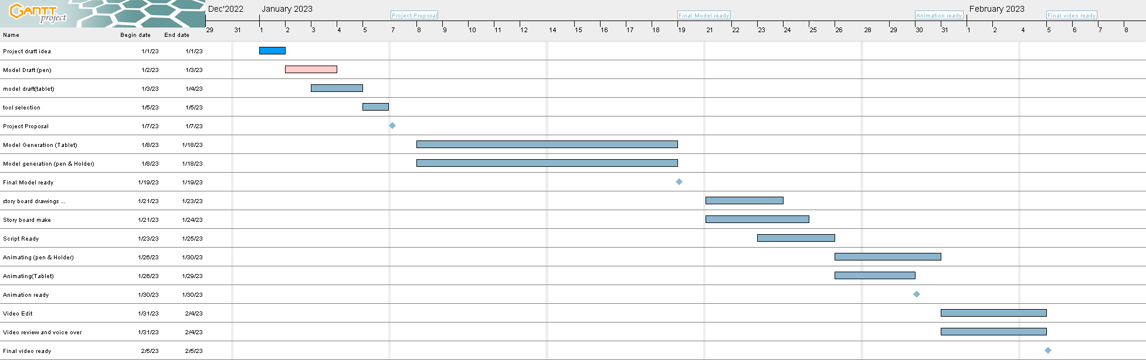

Our project starts from 1st January 2023 and final product will be ready in 8th February.

In whole project we will focus on following things:

* Model Generation
* Video story board
* Script Writings
* Voice recordings
* Sound Design
* Animation
* Videography

**Tools:**

* Blender
* Kdenlive
* Ardour
* Sketchbook
* GanttProject

**Project Brief:**

* 2-3 min video
* Female voice over ( Bangla )
* Suitable sound background
* animation

**Hindrance:**

* Tool Selection
* Learning tools in short time
* Time Management
* Device